
2014 DISTRICT 9800
CLUB SURVIVAL WORKSHOP

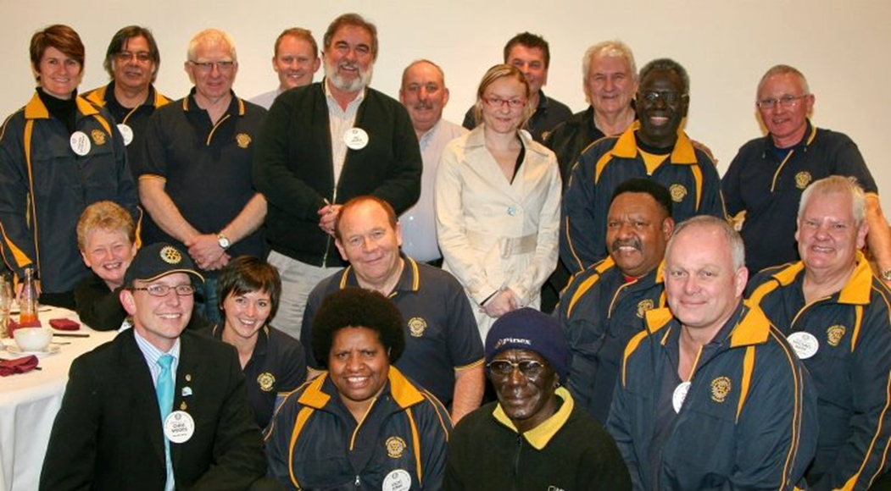
Saturday 30th August 2014
9.30AM to 1.00PM
Lunch from 1.00PM
Registration from 9.00AM

Trinity Grammar School, Kew 3101
Cnr Charles Street & Cotham Road
Melway Map Ref 45 6D
Cost – Free

This major event will provide interactive workshops, hands on training and tips on success stories on how best to recruit, retain members and promote our clubs effectively to our communities, so that our clubs are representative of our communities and sustainable in the long term.

Coffee, tea and lunch included

2012 DISTRICT 9800

Please complete this Registration Form
and return today to Paul Rake:

Email: paul.rake@bigpond.com

For more information contact:

Membership Director Chris Egger: membership@rotarydistrict9800.org

Public Image and Communications Director Chris Don marketing@rotarydistrict9800.org



Members of District 9800 Rotary Clubs are invited to attend this year’s Club Survival Workshop

DATE: Saturday 30th August 2014
REGISTRATION: 9.00 am – 9.30 am
SEMINAR: 9.30 am to 1.00 pm
LUNCH: From 1.00 pm VENUE: Trinity Grammar School, Kew 3101
Centre for the Arts Building Cnr. Charles Street & Cotham Road Melway Map Ref 45 6D
COST: Free (coffee, tea and lunch included)

THIS SEMINAR WILL ASSIST PARTICIPANTS TO RECRUIT & RETAIN MEMBERS AND PROMOTE THEIR CLUBS EFFECTIVELY It is a must for Presidents, President Elects, Club Service Directors, Membership Chairs and Public Relations & Website Chairs

REGISTRATION FORM
Please Return this form by Friday 22nd August 2014

The Rotary Club of ……………………………………………
wishes to register the following for the Club Survival Workshop

Name | Position | Email
There is no cost for participants (fully sponsored by District)
Please complete and return this Registration form to Paul Rake by email to paul.rake@bigpond.com

